Software Quality Engineering
Assignment 01

Name: Abdul Samad Junejo
Enrollment: 01-131232-006

Date: 02/03/2026
Table 1: Binary Search Test Cases (All-Paths & MC/DC Coverage)
Targeting loop condition: (bottom <= top && !found)

Test Case ID | Purpose / Path Covered | Input Array | Search Key | Expected Output (Index) | Result
BS-TC01 | Path 1: Empty Array. Bypasses the loop entirely. | {} | 5 | -1 | Pass
BS-TC02 | Path 2: Key found at mid. Satisfies elemArray[mid] == key. Loop terminates early (!found becomes false). | {10, 20, 30, 40, 50} | 30 | 2 | Pass
BS-TC03 | Path 3: Upper half traversal. Satisfies elemArray[mid] < key. Evaluates bottom <= top as True. | {10, 20, 30, 40, 50} | 50 | 4 | Pass
BS-TC04 | Path 4: Lower half traversal. Satisfies elemArray[mid] > key (the else block). | {10, 20, 30, 40, 50} | 10 | 0 | Pass
BS-TC05 | Path 5: Key not found. Loop exhausts. Evaluates bottom <= top as False while !found is True. | {10, 20, 30, 40, 50} | 99 | -1 | Pass

Table 2: Linear Search Test Cases
Test Case ID | Purpose / Path Covered | Input Array | Search Key | Expected Output (Index) | Result
LS-TC01 | Boundary Case: Empty Array. | {} | 5 | -1 | Pass
LS-TC02 | Best Case/Match: Key is found at the very beginning of the array. | {5, 10, 15} | 5 | 0 | Pass
LS-TC03 | Worst Case/No Match: Iterates through the entire array but key does not exist. | {5, 10, 15} | 99 | -1 | Pass

Table 3: Jump Search Test Cases
Test Case ID | Purpose / Path Covered | Input Array | Search Key | Expected Output (Index) | Result
JS-TC01 | Boundary Case: Empty Array. | {} | 5 | -1 | Pass
JS-TC02 | Standard Match: Key exists and is found via block jumping and linear fallback. | {0, 1, 1, 2, 3, 5, 8, 13, 21, 34} | 5 | 5 | Pass
JS-TC03 | Out of Bounds: Key is larger than the maximum element in the array. | {0, 1, 1, 2, 3, 5, 8} | 99 | -1 | Pass
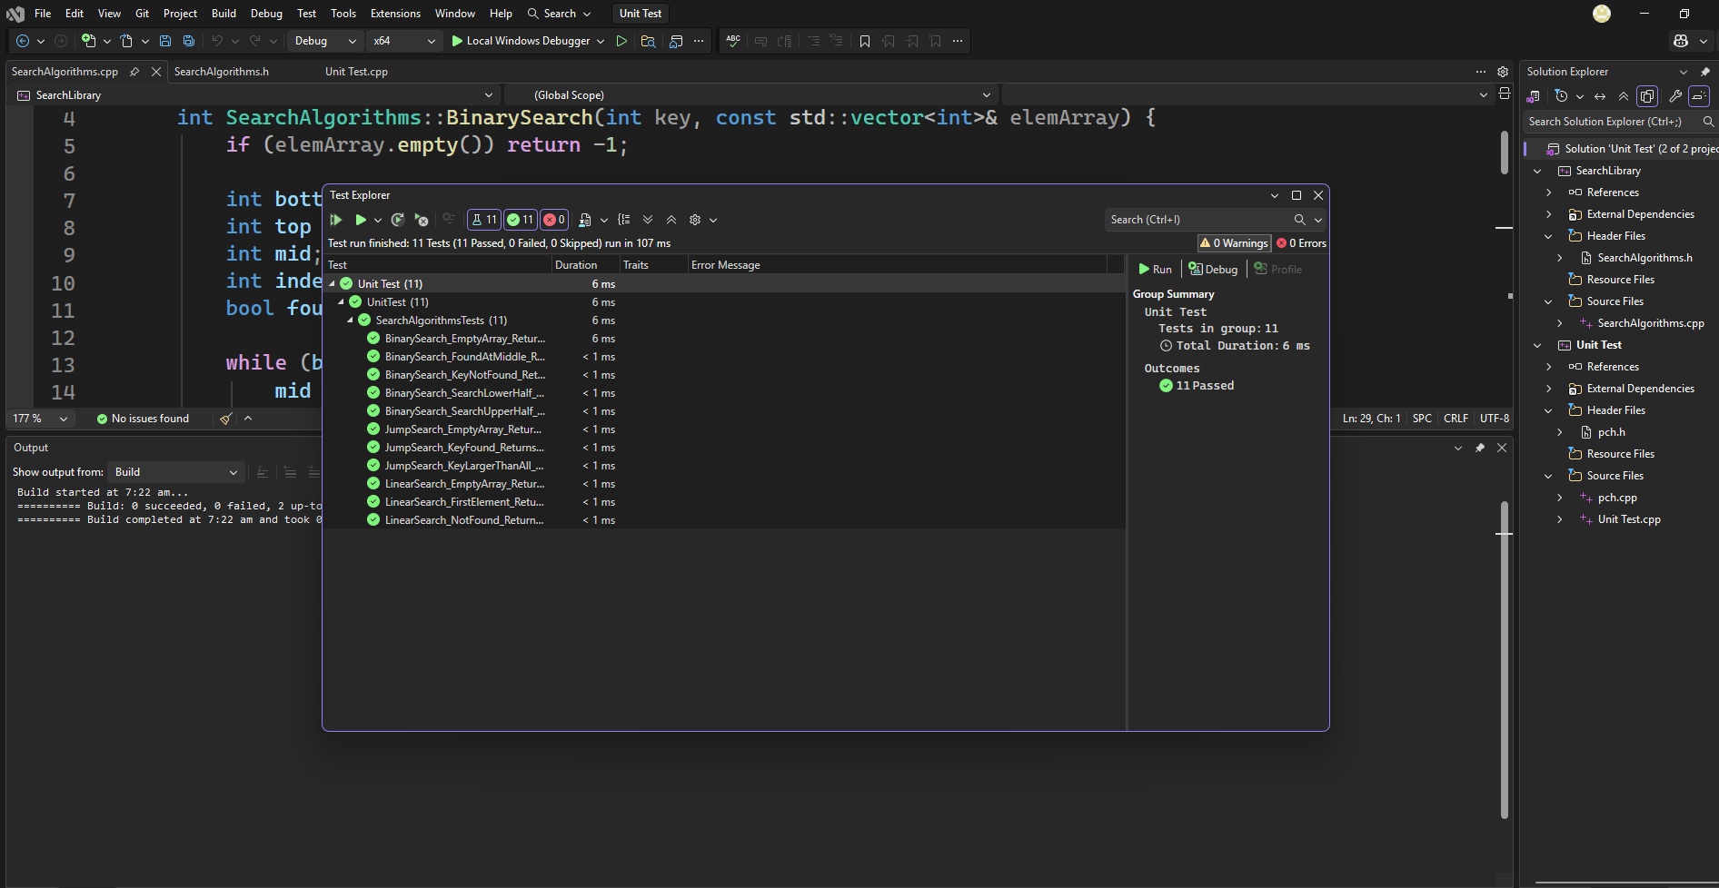
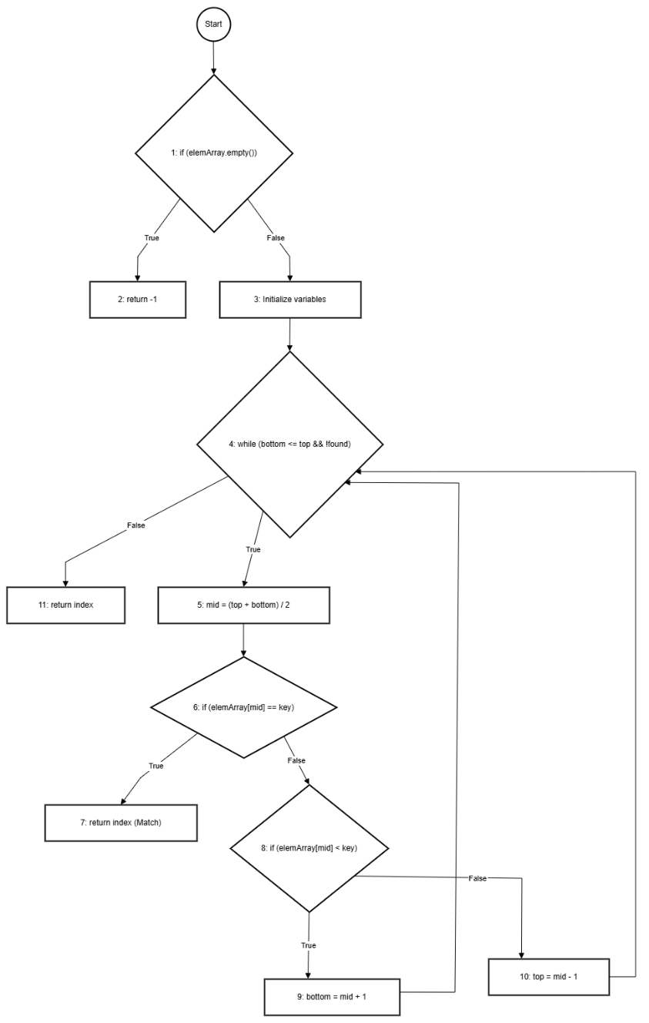

Path for BS-TC01 (Empty Array): Start -> 1 -> 2
Path for BS-TC02 (Match Found): Start -> 1 -> 3 -> 4 -> 5 -> 6 -> 7
Path for BS-TC03 (Upper Half): Start -> 1 -> 3 -> 4 -> 5 -> 6 -> 8 -> 9 -> 4...
Path for BS-TC04 (Lower Half): Start -> 1 -> 3 -> 4 -> 5 -> 6 -> 8 -> 10 -> 4...
Path for BS-TC05 (Not Found): Start -> 1 -> 3 -> 4 -> 5 -> 6 -> 8 -> (9 or 10) -> 4 -> 11

.github/workflows/test.yaml

name: C++ CI Pipeline (MSBuild & Native Unit Tests)

on:
push:
branches: [ "main" ]
pull_request:
branches: [ "main" ]

jobs:
build-and-test:
runs-on: windows-latest

steps:
- name: Checkout Repository
uses: actions/checkout@v4

- name: Add MSBuild to PATH
uses: microsoft/setup-msbuild@v2

- name: Build Solution
run: msbuild SearchLibrarySolution.sln /p:Configuration=Release /p:Platform=x64

- name: Setup VSTest.console.exe
uses: dpauli/setup-vstest@v1

- name: Run Native Unit Tests
run: vstest.console.exe "**\Release\*Test*.dll"

